**1. Write a blog on Difference between HTTP1.1 vs HTTP2**

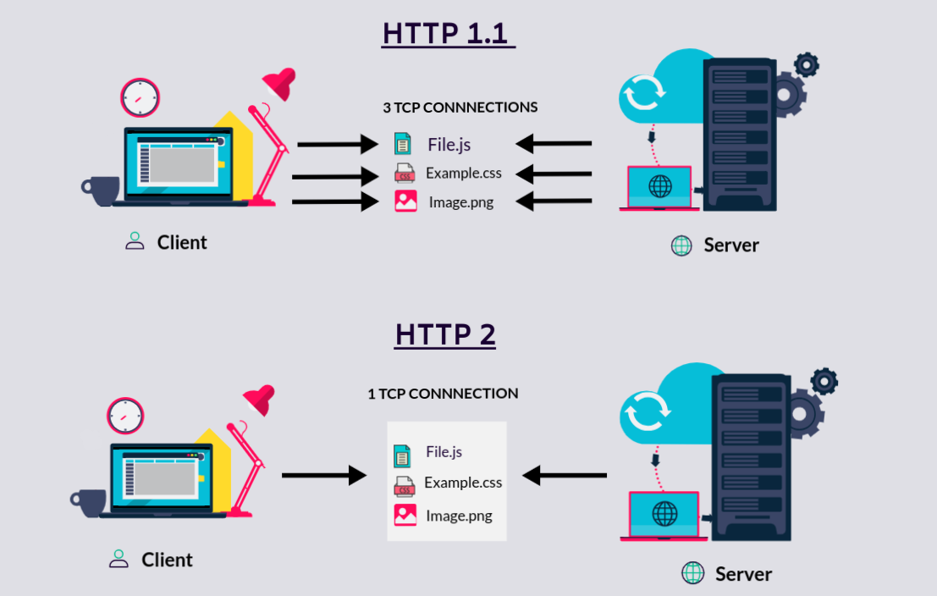

* The first usable version of HTTP was created in 1997. Because it went through several stages of development, this first version of HTTP was called HTTP/1.1. This version is still use on the web.
* In 2015, a new version of HTTP called HTTP/2 was created. HTTP/2 solves several problems that creators of HTTP/1.1 did not anticipate.
* HTTP/2 is much faster and more efficient than HTTP/1.1. HTTP/2 is faster in how it prioritizes content during loading Process.
* HTTP/1.1 loads resources one after the other, so if one resource cannot be loaded, it blocks all the other resources behind it. HTTP/2 is able to use a single TCP connection to send multiple streams of data at once so that no one resource blocks any other resource.
* In HTTP/1.1 each request had to wait for a response before the next request Could be sent. HTTP/2 uses multiplexing to allow multiple concurrent requests and responses over a single TCP Connection.
* HTTP/1.1 relies on the transport layer to avoid buffer overflow, so each new TCP connection requires a separate flow control mechanism. HTTP/2 multiplexes streams within a single TCP connection.
* The major feature differentiates HTTP/2 from HTTP/1.1 is the binary framing layer. Unlike HTTP/1.1, HTTP/2 uses a binary framing layer.
* This layer encapsulates messages — converted to its binary equivalent — while making sure that its HTTP semantics(method, details, header Information, etc) remain Untamed.

**2. Write a blog about objects and its internal representation in Javascript**

In simple terms. “A JavaScript object is a collection of named values having state and behavior (properties and method)”.

For example: Person, car, pen, bike, Personal Computer , Washing Machine etc.

Take the case of cars.

All cars have the same properties, but the property values differ from car to car. All cars have the same methods, but the methods are performed at different times.

Let’s have an example of my favorite merc car and list out its properties(Features):

1. Make: Mercedes
2. Model: C-Class
3. Color: White
4. Fuel: Diesel
5. Weight: 850kg
6. Mileage: 8Kmpl
7. Rating: 4.5

Taking the above as reference, I'll stress up on objects, Object properties and Methods.

**1)Objects:**

The following code assigns a **simple value** (Mercedes) to a **variable** named car:

var car = "Mercedes";

Objects are variables too. But objects can contain many values.

The following code assigns **many values** (Mercedes, C-class, White and soo on) to a **variable** named Car:

var car = {Make: “Mercedes”, Model: “C-Class”, Color: “White”, Fuel: Diesel, Weight: “850kg”, Mileage: “8Kmpl”, Rating: 4.5};

The values are written as **name:value** pairs (name and value separated by a colon).

Syntax:

var <object-name> = {key1: value1, key2: value2,... keyN: valueN};

So, conclusion and definition for JS objects is “JavaScript objects are containers for named values”.

**2)Object Properties**

The name:values pairs (in JavaScript objects) are called **properties**.

var car = {Make: “Mercedes”, Model: “C-Class”, Color: “White”, Fuel: Diesel, Weight: “850kg”,Mileage: “8Kmpl”, Rating: 4.5};

From the above snippet, let’s have a look what falls under property and property value:

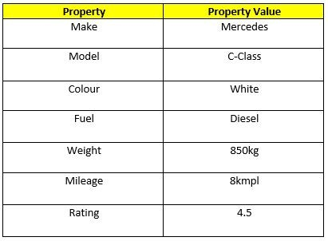

The object properties can be different primitive values, other objects and functions.

Properties can usually be changed, added, and deleted, but some are read only.

**The syntax for adding a property to an object is :**

ObjectName.ObjectProperty = propertyValue;

**The syntax for deleting a property from an object is:**

delete ObjectName.ObjectProperty;

**The syntax to access a property from an object is:**

objectName.property        // Car.Make

//or

objectName["property”]    // Car["Make"]

//or

objectName[expression]   // x = "Make"; Car[x]

So, Conclusion and simple definition for Java Script properties is “Properties are the values associated with a JavaScript object”.

**3)Object Methods**

An object method is an object property containing a function definition.

i.e.,

Let’s assume to start the car there will be a mechanical functionality.

function(){return ignition.on}

and so similar is to stop/brake/headlights on & off, etc.

So, Conclusion and simple definition for Java Script Object methods is “Methods are actions that can be performed on objects.”.